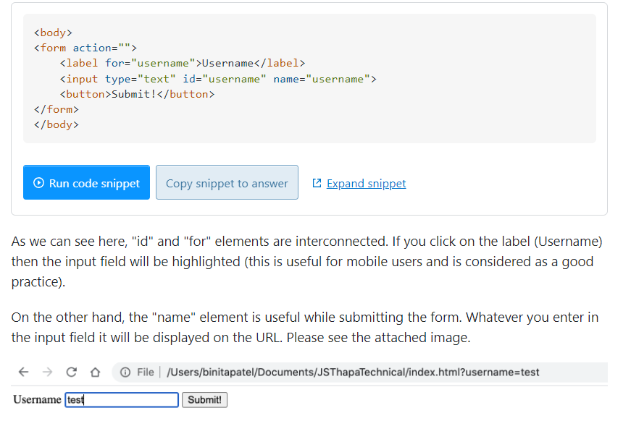action and method on form will be used to post form data by default when clicking submit. onSubmit will be called before the default action (post data and refresh page) is performed, unless preventDefault.